Document A: Churchill Speech

**4 June 1940. House of Commons**

After the Dunkirk evacuation, British Prime Minister Winston Churchill delivers a speech to Parliament

“Even though large tracts of Europe and many old and famous states have fallen or may fall into the grip of the Gestapo and all the odious apparatus of Nazi rule, we shall not flag or fail. We shall go on to the end, we shall fight in France, we shall fight on the seas and oceans, we shall fight with growing confidence and growing strength in the air, we shall defend our island, whatever the cost may be, we shall fight on the beaches, we shall fight on the landing grounds, we shall fight in the fields and in the streets, we shall fight in the hills; we shall never surrender.”

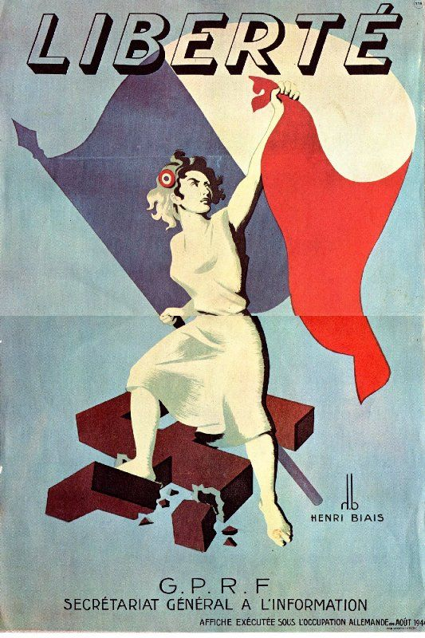Document B: French Poster

Document C Ballot

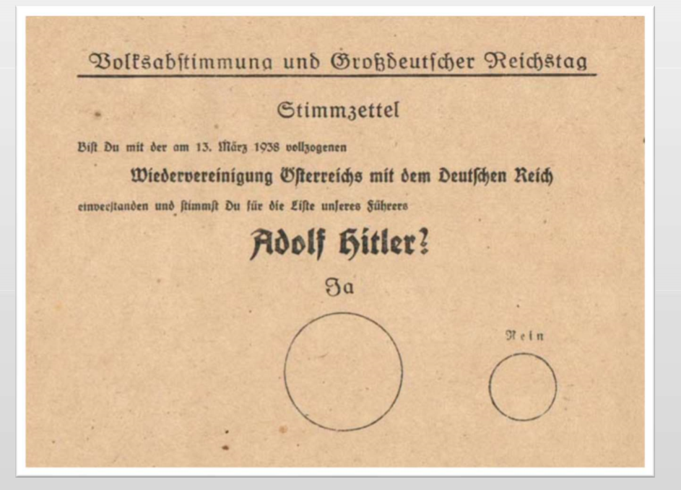

Document D: Cartoon by Theodor Seuss Geisel

Published in PM Magazine May 22, 1941

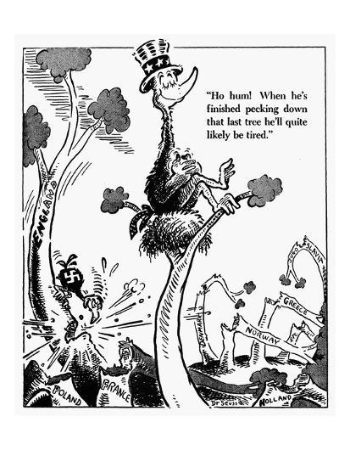

Name: Quang Huynh

Define the term **propaganda**: Ideas used to influence the public opinion for or against a cause.

Complete the chart using the documents provided.

|  |  |  |  |
| --- | --- | --- | --- |
|  | Observations/ Specific Details | Audience – Who is the propaganda intended for? | Purpose – What is it convincing people to believe or do? |
| A | Churchill is instilling determination and giving the people the motivation to keep going. Keep fighting until the end and do not stop. | Parliament | It is convincing people to keep fighting and not give up. Also, it is convincing people to believe that the Nazis are planning something and there needs to be support for the war effort. |
| B | There is a woman carrying a French flag breaking the swastika symbol beneath her. | The citizens | It is making people believe that the Nazis are bad and that people to not have to worry, since the government has it under control. |
| C | I can see the name, Adolf Hitler, with a date. This ballot was made in 1938. | Voters/citizens | The purpose is to have people to support the ballot and vote for it. Support Wiedervereinigung and vote for it. |
| D | The bird has a Nazi symbol on it. Thus, the trees represent the countries that the Nazis have destroyed during the war. Then, America believes that after the Germans are done with their operation, they will be exhausted and not attack anymore countries. | The allied nations | Trying to convince people that the Nazis aren’t going to do anymore damage. |

1. Do you think different formats of each piece of propaganda change its effect?

* You look at the poster
* You hear the speech
* You fill out the ballot
* You view the cartoon

Looking at the different formats of each piece of propaganda, no. Propaganda will still influence people even if it is in different formats. There has to be a message in the format and the message has to be clear and strong.

2. Which document is a more effective piece of propaganda? Why?

I believe the cartoon is a more effective piece of propaganda since the message was clear. You can tell what is happening in the cartoon and it can convince many people.